***Implementation of a Board Game – LUDO***

**Group 12 Details**

1. **Rashika Jain AU2020178**
2. **Kanvi Patel AU2040235**
3. **Jatin Parmar AU2040118**
4. **Kishan Akbari AU2040155**

**Introduction**

Ludo is a strategy board game that can be played by two to four players. In the game, the players need to compete their four tokens from start to end consistent with the die rolls.

**Background**

Ludo is derived from the Indian game Pachisi. The game and its varieties are documented in numerous nations and under different names

**Motivation**

These days the world is moving towards Information Technology, there was a requirement for an enhancement for our manual ludo game.

**Literature Survey**

By doing some research on the topic we found out that Ludo is a board game that can be modelled as a first-order Markov chain as it is memoryless. And the Markov process can be implemented by using a transition matrix

**Pointwise contribution**

* Research and Mathematical Formulation: Kishan, Jatin
* Coding: Rashika, Kanvi, Jatin, Kishan
* Documentation: Kanvi
* Presentation: Rashika

**Mathematical model**

The first-order Markov chain was used. A transition matrix can be used to implement the Markov process. We used graphs, a disjoint union set, and the Dijkstra algorithm in our code. We used a graph as the data structure to connect the coordinates in our matrix. The pawn moves through the graph, traversing the matrix. The Dijkstra Algorithm was then applied. To find the shortest path, the Dijkstra algorithm is used. In our project, we used the Dijkstra algorithm to guide the pawn home.

**Numerical results**

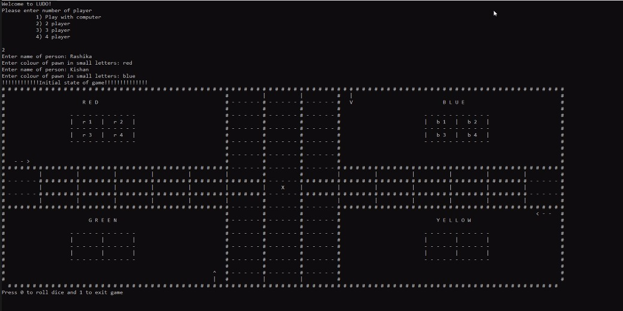

This is our game's user interface.

We roll the dice with zero and can end the game with one.

When we get 6, the pawn will leave the house. We'll have to keep pressing zero until we get a 6.

After we get a 6, we must enter which pawn we want to move.

If we get three 6s in a row, our turn is over.

In the end, whichever player with all of his/her pawns reaches the position in the middle indicated by the sign 'X' wins the game.

**References**

<https://projectworlds.in/python-projects-with-source-code/ludo-game-project-in-python/>

<https://www.geeksforgeeks.org/geometric-algorithms/>